**MySQL Hands on Activities (Day 2) (Table Creation and Data Insertion)**

* **Table Creation**

**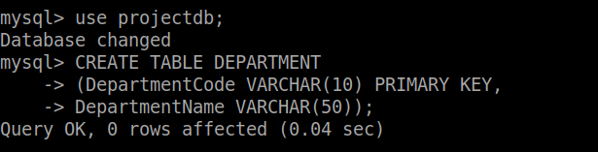  
  
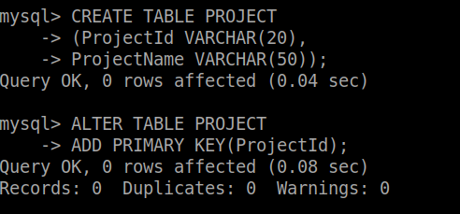  
  
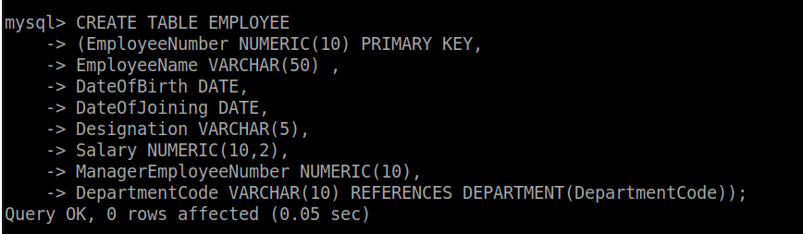**

* **Table Description**

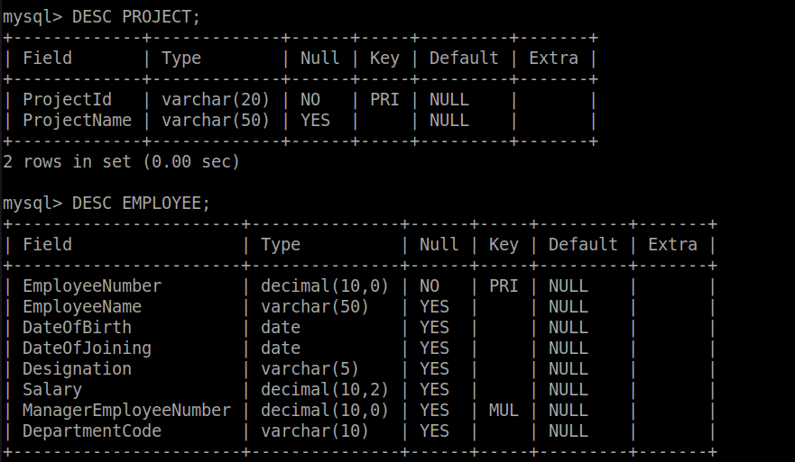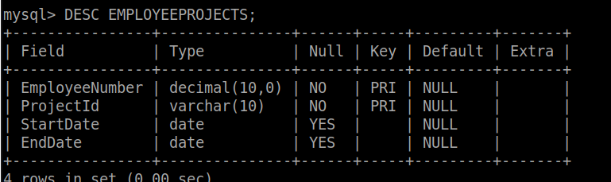

* **Modifying Tables**

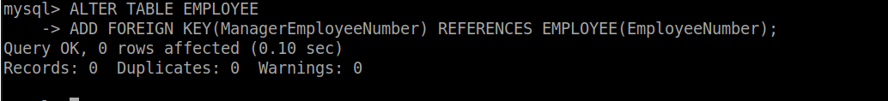

* **Inserting Data**

**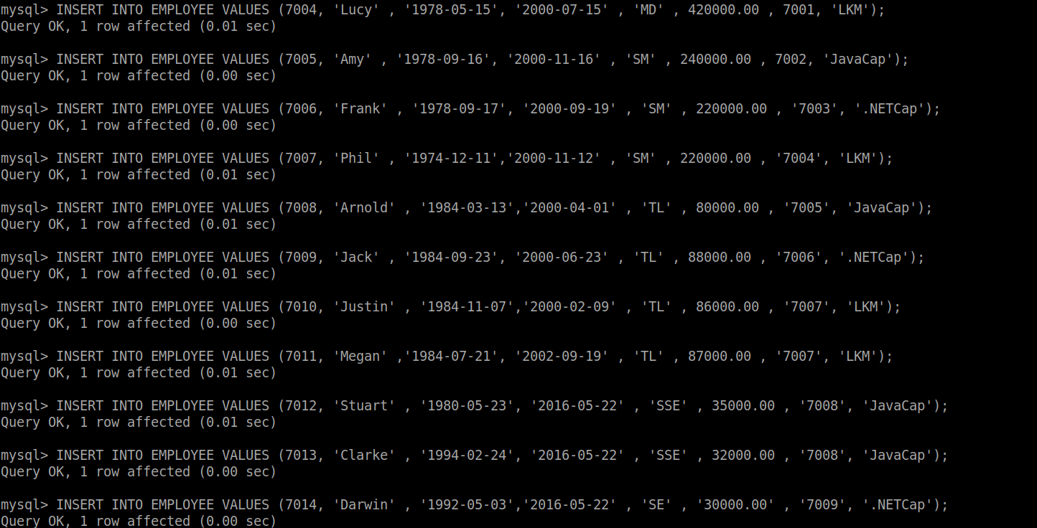  
QUERIES  
Write and execute SQL statements for the following:**

**• Increase the salary of ALL employees by 5%. Save the changes done to the database table.  
  
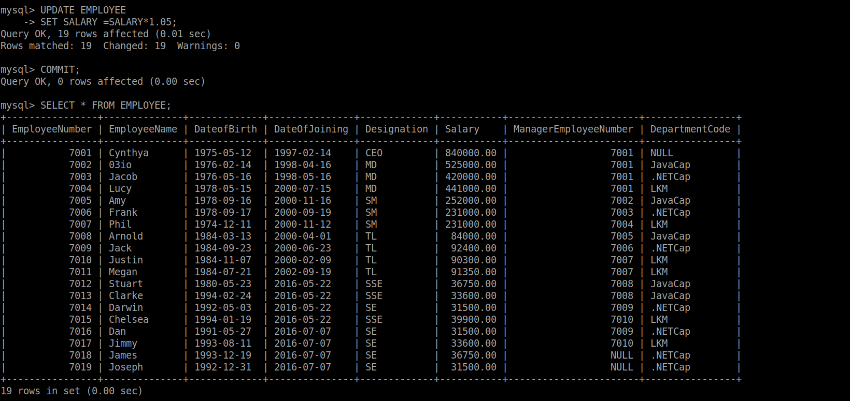**

**• Increase the salary of SSEs by 5% in addition to increase done in the previous statement. Save the changes done to the database table.**

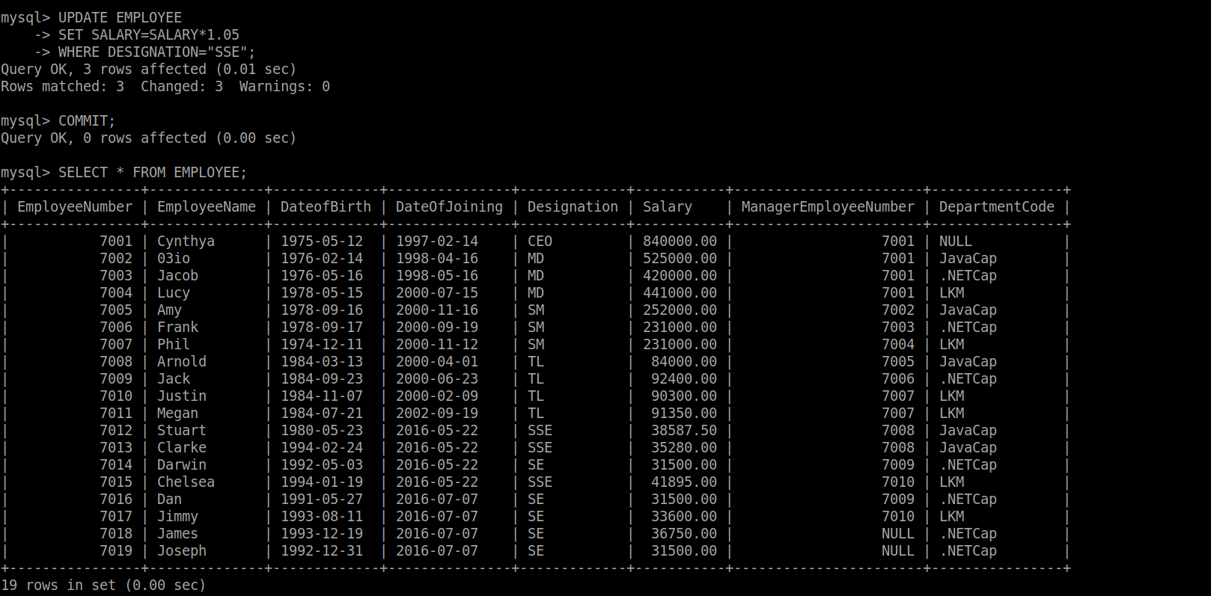

**• Delete ALL rows from “EmployeeProject” table. Undo the changes done to the database table.**

**• Delete rows from “EmployeProject” table if the employee is working for project ‘P1’. Undo the changes done to the database table.**

**• Delete ALL rows from “Department” table. Observe the error.**



**Day-3**

**Write and Execute MySQL queries for the following:**

**• Display the maximum of salary of the company.**

**• Display the average salary of the company.**

**• Display the maximum salary of employees who are TLs.**

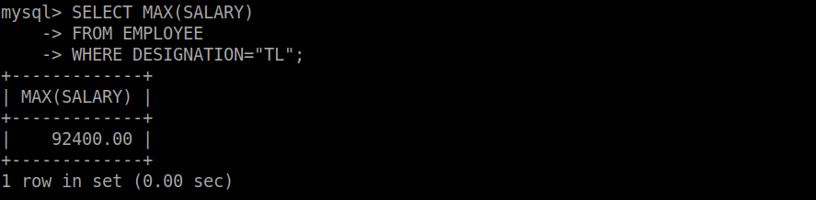

**• Display the total number of employees in the company.**

**• Display the total number of Managers in the company. (If an employee is playing the role of the supervisor for any other employee, then the employee is considered as Manager).**

**• Display the total number SMs in the company.  
**

**Write and Execute MySQL queries for the following:**

**• Display designation and number of employees in each designation.**

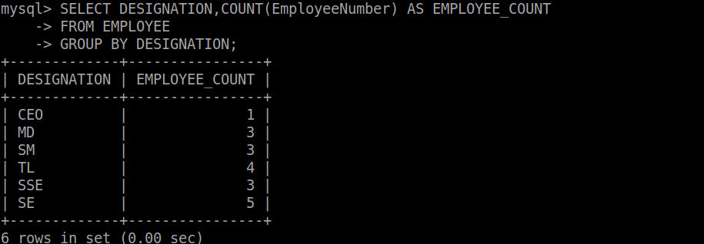

**• Display designation and maximum salary for each designation.**

**• Display Designation and maximum salary for each designation. Display the results in the decreasing order of maximum salary.  
**

**• Display Department_Code and number of employees working for each department.  
**

**• Display Designation and maximum salary for ‘TL’ and ‘SSE.**

**• Display ManagerEmployeeNumber and Number of employees working under the Manager (Exclude Null from ManagerEmployeeNumber column).  
**

**• Display DepartmentCode and NumberOfEmployees if the department has more than 5 employees.  
**

**• Display Department Code and average salary if the average salary of the department is more than INR150,000 (Exclude Null under Department Code column).  
**

**• Display Designation and average salary of each designation for “LKM” department if the average salary is more than INR 35,000. Display the results in the increasing order of average salary.**

**• Display Project_Id, number of employees working in the project. Display the results in the decreasing order of number of employees (Exclude the results if the enddate is not null).  
**

**• Display EmployeeName and DateOfBirth of employees who were born in 90’s (1990 to 1999). The DateOfBirth must be displayed in ‘DD-Mon-YYYY’ format.   
  
